Creating Personal Mythologies
With Kirsten Stingle and Christine Kosiba
March 20-22, 2020; 10am - 5pm

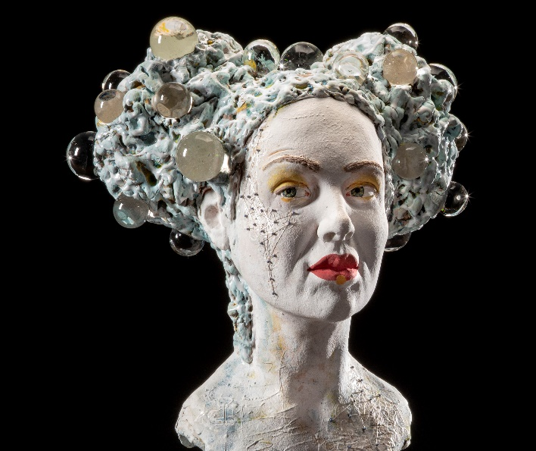

Description:
In this 3-day workshop, Kirsten Stingle and Christine Kosiba will guide participants in expanding their narrative vocabulary by combining human and animal forms to create their own mythologies. Proportion and anatomy will be covered as well as the power of gesture and expression in storytelling. Students will build a life size head and raven and then combine the forms in order to create their own narratives. Different building styles and techniques will be offered that participants can adapt to their own studio practice. Individual attention and problem solving will be emphasized. Beginners through intermediate. Prior figure experience is not required. Class size is limited to 12.

Class Fee:
$550; a deposit of $250 will be required to reserve your spot. No deposits will be refunded after January 1, 2020. To register, email kirsten@kirstenstingle.com or call at 678-923-3412. Checks and Paypal are accepted. The balance of the workshop is due a month prior to the workshop (February 20th, 2020).
There will be an additional lab fee of $45 to cover clay and the cost of firing due the first day of class.

Location:
Norma Yuskos will be hosting the workshop in her large, beautiful facility located in Encinitas, CA (20 miles north of San Diego). For questions regarding the facility, please contact Norma at yuskos@cox.net or 760-753-3792.
Materials List:
- Favorite clay tools including cutting wire, loop tools, various carving and loop tools.
- Fork for scoring
- Spray bottle
- Sharp knife for cutting clay
- Turntable
- 1 ware board approximately 12” x 12”
- 12” x 12” section of craft foam
- 1x 1/2” dowel (12” long)
- Small sponges
- Soft and hard ribs
- Variety of small paint brushes
- Dry cleaning plastic
- Please bring your own lunch.

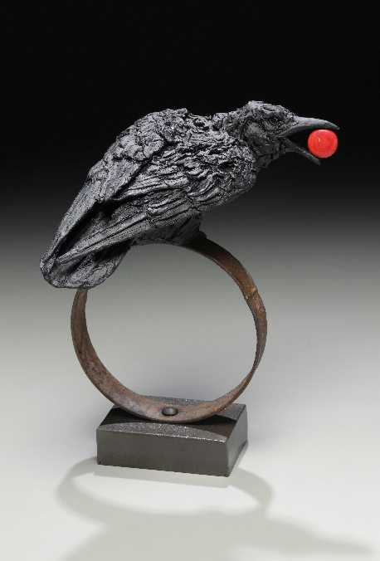

To learn more about Kirsten’s and Christine’s work: www.kirstenstingle.com
www.christinekosiba.com

