Predator and Prey Totem Workshop
March 17th and 18th, 2020

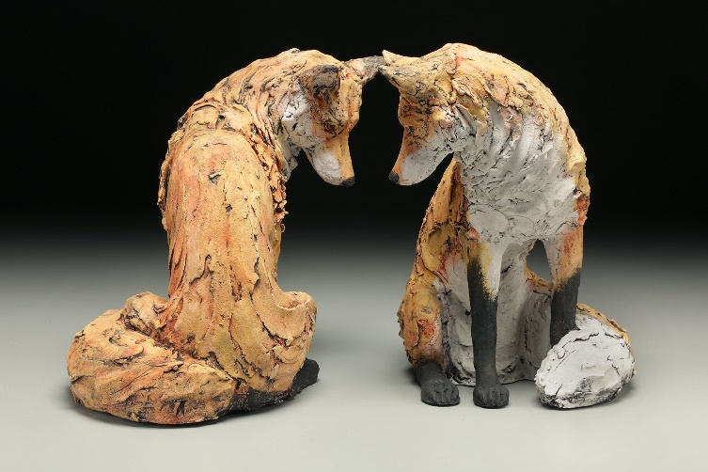
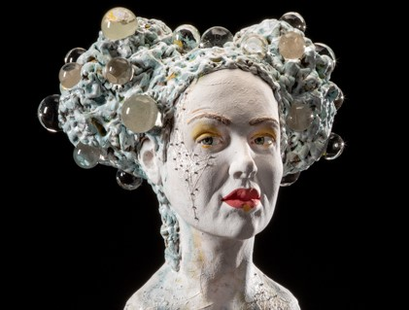

Teachers:
Kirsten Stingle: www.kirstenstingle.com
Christine Kosiba: www.christinekosiba.com

In this two-day workshop, Kirsten and Christine will guide participants in creating a personal totem, combining human and animal imagery. We will explore the human-animal relationship and the conceptual potential of this visual narrative. Using a simple armature and basic hand building techniques, we will sculpt one human head and two animal heads. Each head will be approximately 4-6” high. Focus will be on creating personal narrative and symbolism, as well as developing a personal aesthetic. Basic proportions and anatomy will be covered as well as discussion of textural surface imagery. Discussions will include possible finishing techniques. A $200 deposit is required for registration at PayPal.me/kirstenstingle.

When: March 17 and 18
Where: Julie Dickey’s house, Fullerton CA
Cost: $400
Questions or concerns: kirsten@kirstenstingle.com

